Project: Website Design and Development
Client Website Link: https://www.zunoks.com/

Note: Both the websites are from the same organization. The client wants to combine these two websites into one. Must understand the client's business before moving to UI/UX.

Reference links:

- Mckinsey and Company - https://www.mckinsey.com/
- BCG - https://www.bcg.com/
- Deloitte - https://www.deloitte.com/bd
- Accenture - https://www.accenture.com/en
- Bain and Company - https://www.bain.com/
- Korn Ferry - https://www.kornferry.com/
- The Talent Games (Bangladeshi) - https://thetalentgames.com/

Project Objective
Create a modern, professional consulting website prototype that strengthens ZUNOKS's digital positioning, presents its service portfolio more effectively, establishes credibility through case studies and thought leadership, and improves potential client engagement and enquiry generation. Client recruits CXO level employees for top organizations. So they have a very clear mindset and are very conscious about their branding.
Key Factors: Few features missing from their current website
- Case studies and client-impact showcase
- News and Blogs
- Career
- CSR/Social Impact
Guidelines:
- Must go through all the reference websites to understand the content flow of the homepage.
- Use dummy data to showcase a few sections if necessary(Example: Clients Logo showcasing)
- Use dummy relevant pictures and contents for the site.
- Must follow their brand guidelines. - Attached with the email.
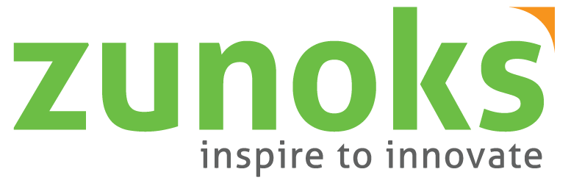
Client Logo:

